A Simple Math Problem
Time Limit: 3000/1000 MS (Java/Others) Memory Limit: 32768/32768 K (Java/Others)
Total Submission(s): 8590 Accepted Submission(s): 5287
Problem Description
Lele now is thinking about a simple function f(x).
If x < 10 f(x) = x.
If x >= 10 f(x) = a0 * f(x-1) + a1 * f(x-2) + a2 * f(x-3) + …… + a9 * f(x-10);
And ai(0<=i<=9) can only be 0 or 1 .
Now, I will give a0 ~ a9 and two positive integers k and m ,and could you help Lele to caculate f(k)%m.

Input
The problem contains mutiple test cases.Please process to the end of file.
In each case, there will be two lines.
In the first line , there are two positive integers k and m. ( k<2*10^9 , m < 10^5 )
In the second line , there are ten integers represent a0 ~ a9.

Output
For each case, output f(k) % m in one line.

Sample Input
10 9999
1 1 1 1 1 1 1 1 1 1
20 500
1 0 1 0 1 0 1 0 1 0

Sample Output
45
104

Author
linle

Source
2007省赛集训队练习赛（6）_linle专场

Recommend
lcy | We have carefully selected several similar problems for you: 1588 3117 2276 2256 2604

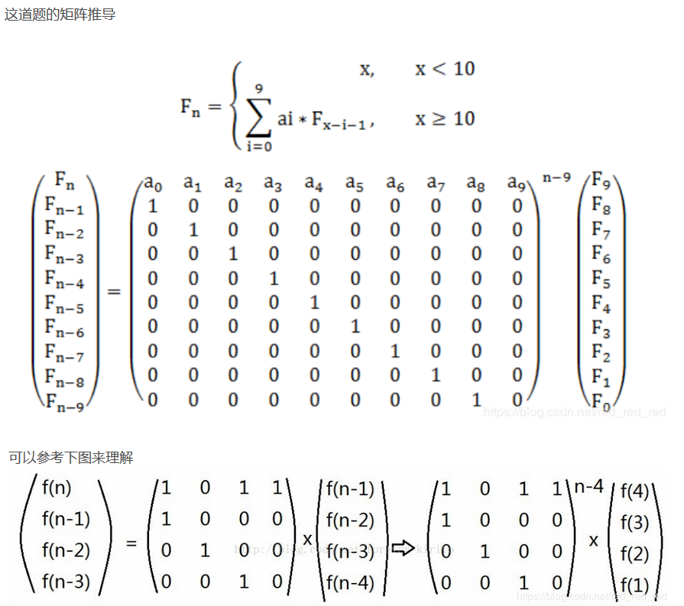

#include<map>
#include<set>
#include<cmath>
#include<queue>
#include<stack>
#include<cstdio>
#include<vector>
#include<bitset>
#include<string>
#include<cstdlib>
#include<cstring>
#include<fstream>
#include<sstream>
#include<iomanip>
#include<iostream>
#include<algorithm>
#include<functional>
#define INF 0x3f3f3f3f //1061109567
#define llINF 9223372036854775807
#define pi 3.141592653589793
#define ll long long
using namespace std;
ll mod;
struct node
{
int mat[15][15];
}x,y;
int n;
node a;
node mul(node x,node y,int num)
{
node tmp;
for(int i=0;i<n;i++)
{
for(int j=0;j<num;j++)
{ tmp.mat[i][j]=0;
for(int k=0;k<n;k++)
{
tmp.mat[i][j]+=(x.mat[i][k]*y.mat[k][j])%mod;
}
tmp.mat[i][j]=tmp.mat[i][j]%mod;
}
}
return tmp;
}
node ksm(node x,int num)
{ node y;
for(int i=0;i<n;i++)
for(int j=0;j<n;j++)
if(i==j) y.mat[i][j]=1;
else y.mat[i][j]=0;
while(num)
{
if(num&1)
{
y=mul(y,x,n);
}
x=mul(x,x,n);
num=num>>1;
}
return y;
}
int main()
{ n=10;
ll k,m;
while(~scanf("%lld %lld",&k,&m))
{ mod=m;
node base; node now;
memset(base.mat,0,sizeof base);
for(int i=0;i<10;i++)
scanf("%d",&base.mat[0][i]);
if(k<10) {printf("%lld\n",k);continue;}
for(int i=1;i<10;i++)
base.mat[i][i-1]=1;
memset(now.mat,0,sizeof now);
for(int i=0;i<10;i++)
{
now.mat[i][0]=9-i;
}
node ans=ksm(base,k-9);
ans=mul(ans,now,1);
cout<<ans.mat[0][0]<<endl;
}
return 0;
}

